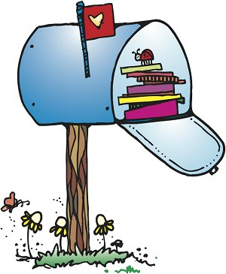**Olney Classroom**

**September**

**2018**

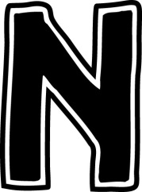   

**Reminders**

**9/11: No Cook Night at Chipotle**

**9/14: PTO Trivia Night**

**9/19: ELL Curriculum Night 6-7pm**

**9/21 Early Release**

**9/22 PTO and Big Hollow Family Reading Day**

**9/24- 9/28: Reading Week and Book Fair**

**9/24: Grandparents/Special Friends Day**

**9/26: Book Fair Family Night/ Reading Night Festival 5-8pm**

**9/28: Scholastic Orders Due!**

**10/1: Reading logs**

**Wednesdays**- Library books due

**This month….**

In addition to getting to know one another, learning 1st grade routines & procedures, and becoming comfortable in our new class, we will be covering the following in academic skills:

**Reading:** Kindergarten review, short vowels, parts of a book, character, setting, and plot, fiction/non-fiction

**Grammar/Writing:** identifying sentences, subject and action parts of sentences, writing simple sentences, review of letter formation and nouns

**Math:** decomposing numbers, constructing number bonds, writing number sentences, addition problem solving

**Social Studies:** Unit 1: various groups, discussion of rules, school and home routines, good citizens, our country

**Science:** Mystery 1, I wonder… learning to find out the answers to our questions.

Wanted

Starburst & red, green and yellow tissue paper!



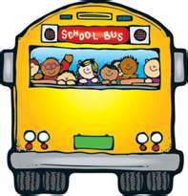Conference Reminder!

Nov. 1st. 11am-7pm!

If you are still in need of a spot, I have time slots available from 12-12:45 and 1:15-2:30.

For those of you who have signed up, a reminder sheet will be coming home soon.

**Please be sure your child has gym shoes (and extra socks) to be left at school ☺**

**Reading Logs!**

**Reading logs are due monthly. The students are required to read nightly. Please fill out the log nightly to help you keep up. It’s due Oct. 1st. Reading Logs are part of your student’s grade.**