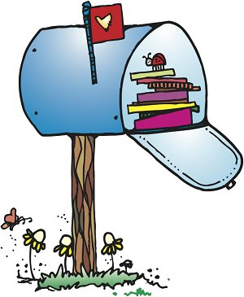**Olney Classroom**

**November**

**2018**

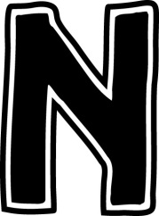 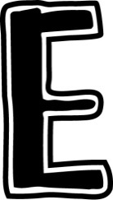 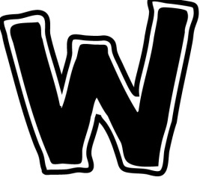 

This month…

Math: continue simple addition & subtraction by using the

“make 10” strategy, solving number stories

Science/Social Studies: Pilgrims/Indians – The history of Thanksgiving, pumpkins, elections/voting

Reading:

Open Court: Unit 3

Spelling: Ks, (x), ed, ea, wh, sh, ch, tch, th, and r-controlled words

Grammar: Verbs

Writing: Discuss narrative writing (We wrote our own story about a time we had an Ouchy!)

**Reminders**

11/23-24: Thanksgiving Break

11/30: Scholastic Book Orders Due!

12/3: Reading Logs Due!

12/5: PTO Pizza Throw Down

12/7: Early Release

12/21:Early Release

12/22: Start of Winter Break!

Wednesdays-Library Books

**Donations**

**\*Green, Red & White Tissue Paper**

**Conferences**

**I enjoyed talking with everyone about your fabulous children!**

Holiday Party!

In lieu of our Holiday Party, we will be having a movie, popcorn, pajama and hot cocoa day to celebrate winter break. This will take place the morning of Dec. 21st. I will be sending a sign up genius for donations☺

Thanks in advance!

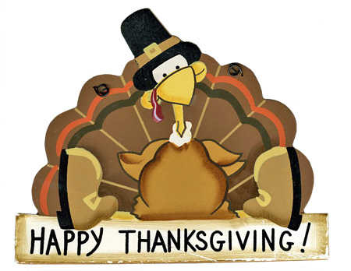

Winter is here! 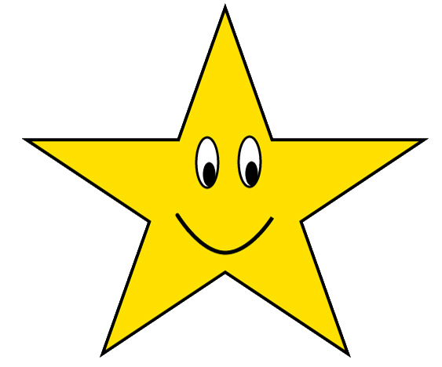

Reminder: If your child would like to play in the snow, they need to have their five stars!

*coat * hat * gloves *boots *snow pants

**Change of clothes!**

**I am going to send home any clothes your student brought at the beginning of the year. Please swap it out for pants and long sleeves. We had several mishaps already and all the kids have are shorts☹**

