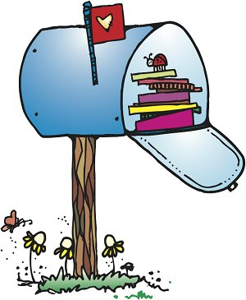**Olney Classroom**

**October**

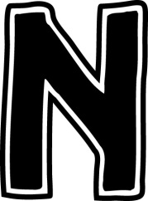  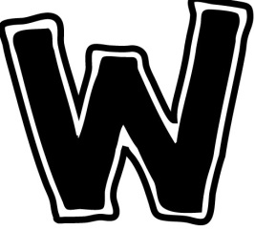 

**Reminders**

10/19: Early Release @ 1:30

10/23-10-31: Red Ribbon Week

11/1 Parent Teacher Conferences

**Wednesdays**- Library books due

**This month….**

**Reading:** Working on sound spelling (al, all, K, ck, r, f, ff, s, ss, g, j, dge, u, z, zz). High Frequency Words (call, look, was, what, big, got, all, if ,to, get, ask, of, as, he, his and just).

**Grammar/Writing:** review of letter formation, work order, identifying telling sentences, writing asking sentences

**Math:** continue simple addition & subtraction, writing number sentences, subtraction problem solving, addition and subtraction strategies

**Social Studies:** Unit5, “This is our Country”-early explorers, early American history, and national holidays, Christopher Columbus, National Fire Safety Month.

**Reading Logs**

**Monthly reading logs have started! Please encourage your child to read nightly☺**

**They are due back between Oct. 31st and Nov. 5th!**

**Halloween Party!**

Calling all junior ghosts and goblins!

Our Halloween party is brewing.

Wednesday, Oct. 31st 9:00-10:00.

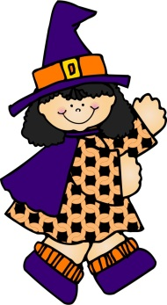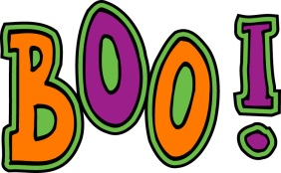

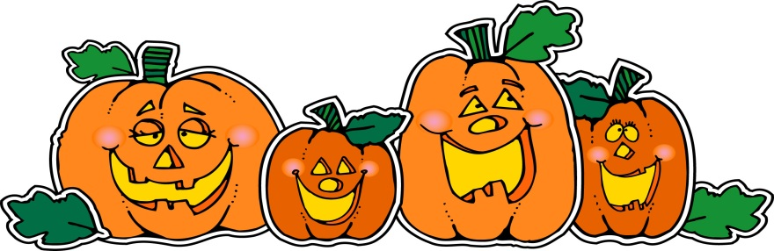

**Wanted!**

1 case of small water 20 count

Halloween Plates 20 count

Halloween Napkins 20 count